**DOCUMENT CONVERSION ENGINE**

**TEST PLAN**

Table of Contents

Introduction 3

1.1 Objectives 3

1.2 Team Members 3

2 Scope 3

3 Assumptions / Risks 4

3.1 Assumptions 4

3.2 Risks 4

4 Test Approach 4

4.1 Manual Testing 4

4.2 Test Automation 4

5 Test Environment 5

6 Milestones / Deliverables 5

6.1 Test Schedule 5

6.2 Deliverables 5

# Introduction

The Test Plan has been created to communicate the test approach to team members. It includes the objectives, scope, schedule, risks and approach. This document will clearly identify what the test deliverables will be and what is deemed in and out of scope.

## Objectives

The document conversion engine is a new tool with the functionality to convert supported electronic document and image formats to plain text, then storing both converted text and file metadata. A user will also have the functionality to export any stored data to their local drive. The test team is responsible for testing the product and ensuring it meets their needs. Testing will be conducted by internal development and test teams only; users will not be testing before release.

Stability of must have functionality is considered more important than the delivery date in this project.

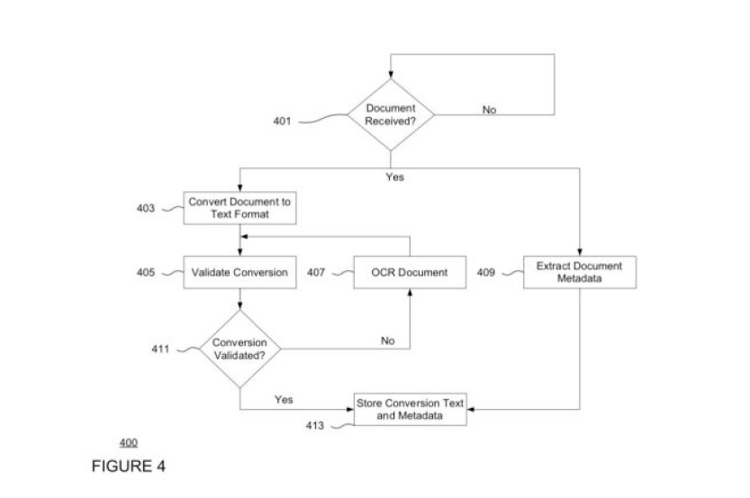

## Team Members

|  |  |
| --- | --- |
| **Resource Name** | **Role** |
|  |  |
|  |  |
|  |  |

# Scope

The initial phase will include all ‘must have’ requirements. These and any other requirements that get included must all be tested. At the end of Phase 1, a tester must be able to:

1. Convert all supported document formats and image files to plain text
2. Retrieve metadata from original files
3. Export converted text to local drive
4. Export metadata to local drive
5. Search for converted document in the following ways:
   1. via file name and date
   2. via content text match
   3. via other document metadata

As the team works with the product, they will define the needs for the second phase.

# Assumptions / Risks

## Assumptions

This section lists assumptions that are made specific to this project.

1. Supported formats will be decided upon beforehand

## Risks

The following risks have been identified and the appropriate action identified to mitigate their impact on the project. The impact (or severity) of the risk is based on how the project would be affected if the risk was triggered. The trigger is what milestone or event would cause the risk to become an issue to be dealt with.

|  |  |  |  |  |
| --- | --- | --- | --- | --- |
| # | Risk | Impact | Trigger | Mitigation Plan |
| 1 |  |  |  |  |
| 2 |  |  |  |  |
| 3 |  |  |  |  |

# Test Approach

The project is using an agile approach, with weekly iterations. At the end of each week the requirements identified for that iteration will be delivered to the team and will be tested.

Exploratory testing will play a large part of the testing as this is a new tool and the team will be learning as they go. Tests for planned functionality will be created and added as there are further iterations.

## Manual Testing

Manual test cases and guidelines will be created for all must have functionality, with feature stability in mind. All manual test cases will be executed.

## Test Automation

Automated unit tests are part of the development process. Further automated tests will be created, and manual test cases will be converted where necessary.

# Test Environment

No new test environments are required for this project. All current test environments will be used.

# Milestones / Deliverables

## Test Schedule

The initial test schedule follows……….

|  |  |  |  |  |
| --- | --- | --- | --- | --- |
| **Task Name** | **Start** | **Finish** | **Effort** | **Comments** |
| Test Planning |  |  |  |  |
| Review Requirements documents |  |  |  |  |
| Create initial test estimates |  |  |  |  |
| First deploy to QA test environment |  |  |  |  |
| Functional testing – Iteration 1 |  |  |  |  |
| Iteration 2 deploy to QA test environment |  |  |  |  |
| Functional testing – Iteration 2 |  |  |  |  |
| System testing |  |  |  |  |
| Regression testing |  |  |  |  |
| Resolution of final defects and final build testing |  |  |  |  |
| Deploy to Staging environment |  |  |  |  |
| Performance testing |  |  |  |  |
| Release to Production |  |  |  |  |

## Deliverables

|  |  |  |
| --- | --- | --- |
| **Deliverable** | **For** | **Date / Milestone** |
| Test Plan | Project Manager; QA Director; Test Team |  |
| Traceability Matrix | Project Manager; QA Director |  |
| Test Results | Project Manager |  |
| Test Status report | QA Manager, QA Director |  |
|  |  |  |
| Metrics | All team members |  |
|  |  |  |